**GENERATING NOISY SIGNAL**

Noisy signal can be generated from the desired signal through two simplest ways

1. Addition of noise to the desired signal

s(t) = x(t) + n(t);

1. Multiplication of noise with the desired signal

s(t) = x(t)n(t);

In this experiment we will try to mix the white noise that was generated previously.

Noise ,n(t) is

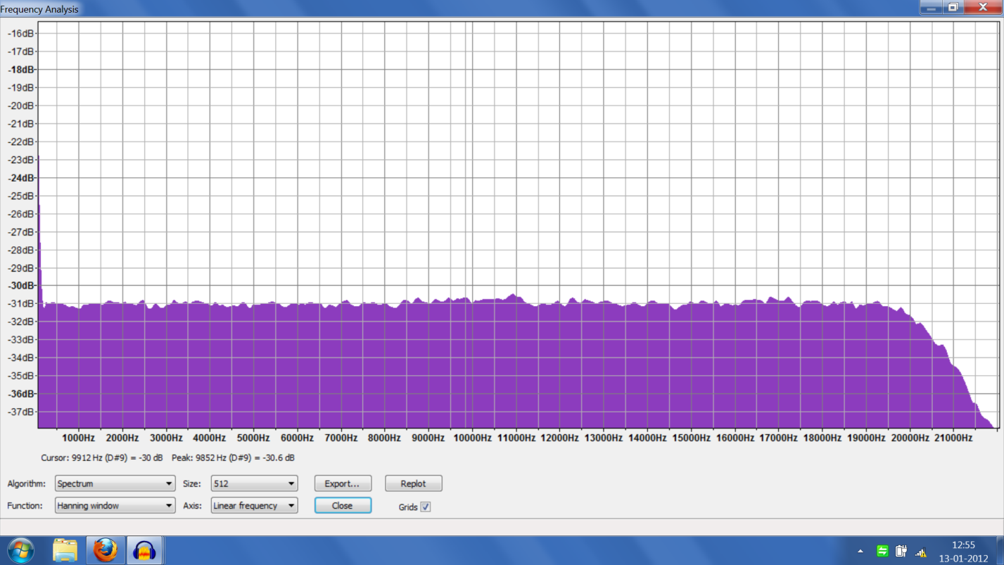

**ADDITION :**

Addition can be done by using the summer circuit which can realised using op amp.

The output of the op amp is noise added signal.

When a single tone sine wave is added to the signal the peaks would be visible at frequency of sine wave indicating the addition , there would also be peaks at harmonics of sine wave.

Spectrum at frequency of sine wave 10Khz

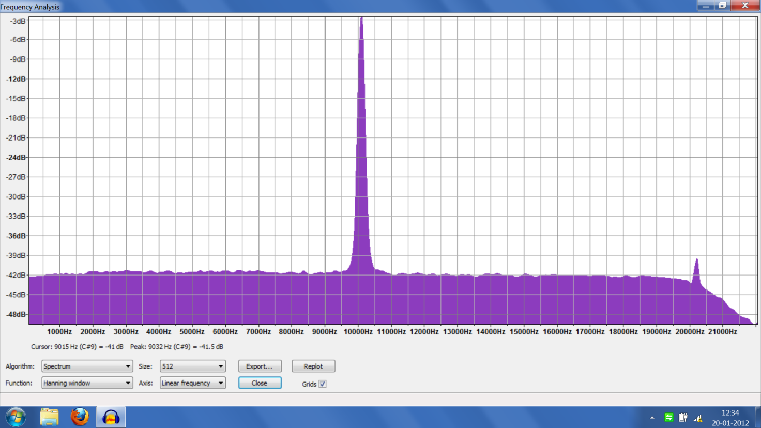

At 5Khz

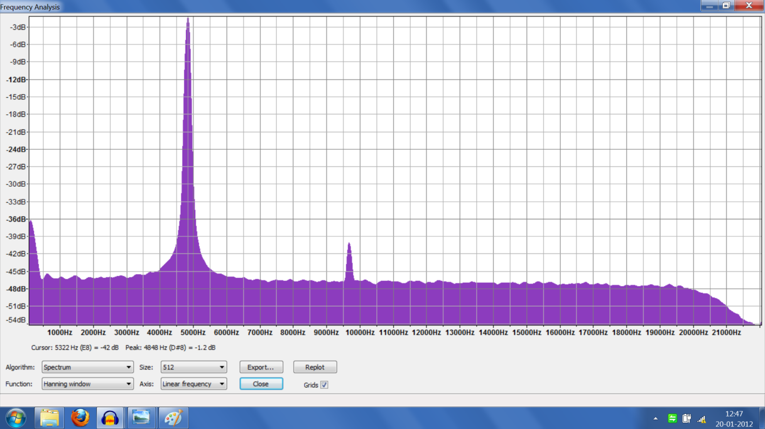

**MULTIPLICATION (singletone) :**

Multiplication of noise to signal can be realised using AD 633JN.

Noise multiplied signal :

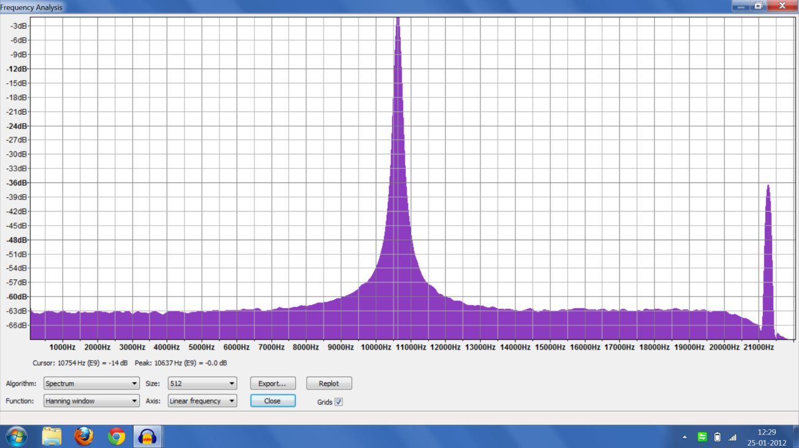

**Addition and multiplication of baseband signal :**

Triangular wave form of frequency 1khz is chosen for the following purpose and it passed through a lpf. We get the baseband signal.

Low pass filtered triangular wave’s Spectrum :

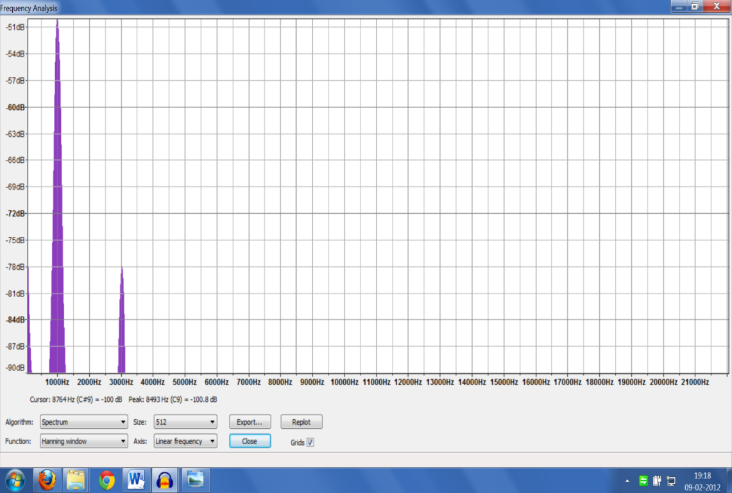

Now when the noise is added to signal the spectrum is

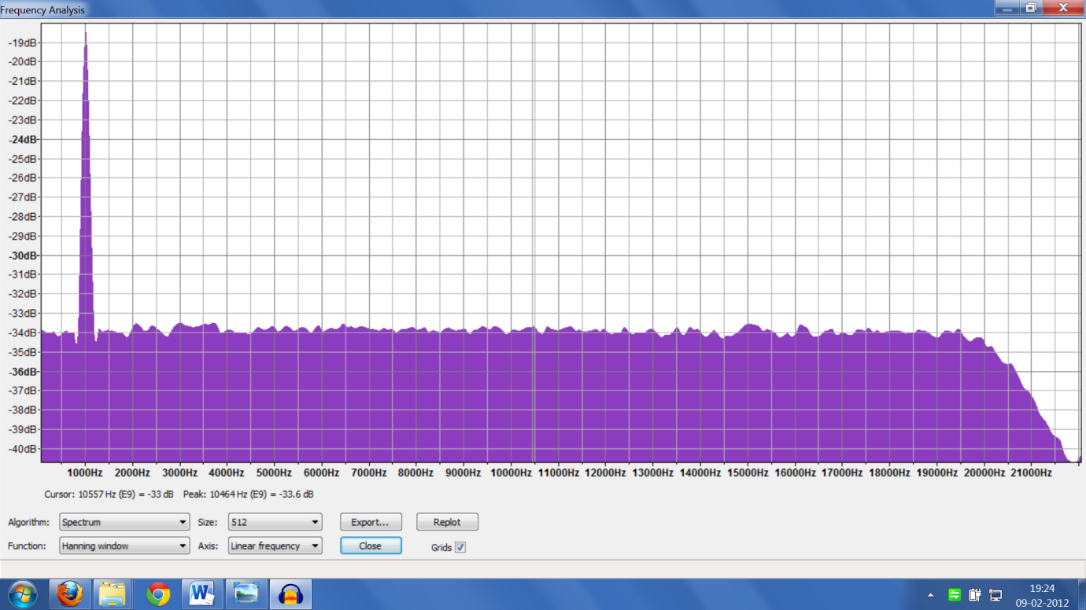

Multiplication :

Our output of the multiplier was not as expected. As spectrum should be a flat band but we observed some peaks in spectrum which are not desired.